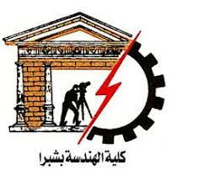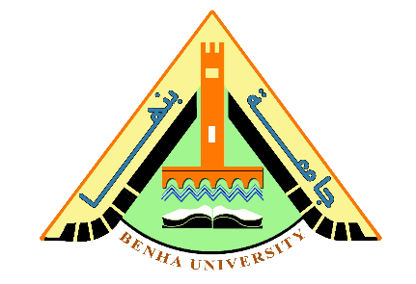 (ECE001) Report

Shobra faculty of engineering

Name: Ahmed Mahmoud Sanad Abdalla

B.N: 19

Sitting number: 136

Topic: Operating System

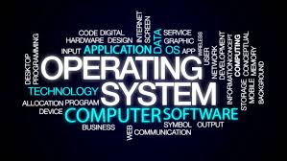

Actually, I choose this topic because the invention of operating system one of the most important development

In recent ages, so we all should know about OS as computers now and in the future will be replaced by written regulations.

**Operating system applications**:

* An **operating system** has **three main** functions:

(1) manage the computer's resources, such as the central processing unit, memory, disk drives, and printers, (2) establish a user interface, and (3) execute and provide services for applications software.

* **Mobile Operating systems:**

An OS is a software interface that is responsible for managing and operating hardware units and assisting the user to use those units. For mobile phones, OSs have been developed to enable users to use phones in much the same way as personal computers were used 1 or 2 decades ago.

